NCHIMA TRUST NEWSLETTER
Winter 2010

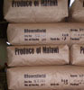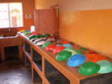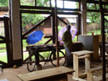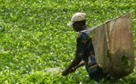

Thanks to the continuing generosity of Nchima Trust sponsors and regular donors all over the world, our students, older people and children in Malawi continue to thrive. The Trust supports many projects; funding secondary school children, agricultural and medical courses, at college and vocational level, as well as teacher and nurse training, and adult literacy courses. Our Community Centre at Thyolo is now under new management with big plans for the future.

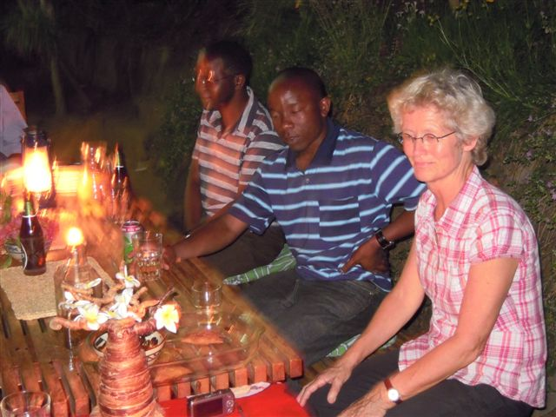
Life in Malawi is still tough - there is serious concern about the impact of AIDS, Malaria and TB; there are now a million orphans in a population of 15 million; deforestation, large scale irrigation and engineering schemes have taken their toll on the environment. Jobs are difficult to find but economic growth is relatively strong, and there are always many reasons to be encouraged by this beautiful country with its wonderful people.

Our tireless volunteer, Jeanette Heikens, and her team of helpers, including Frank Mkumba, who Nchima supported during his degree from Chancellor University, have begun many new projects, distributing the Trust’s funds wisely and helping individuals in need of guidance.
Our Malawi representative, Jeannette Heikens
and her assistant, Frank Mkumba

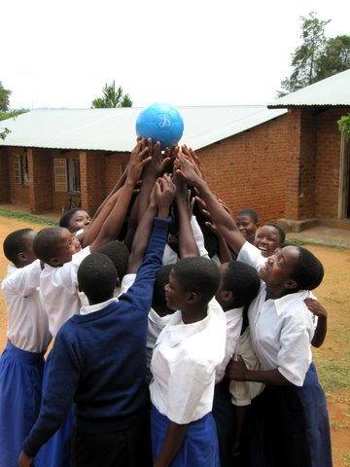
The Trust has funded a much needed ventilator for Zomba Hospital. New seeds have been bought for the land at the Community Centre and banana and papaya trees planted, fertilised by manure from the Ecodome toilet. Our students are working hard; all are part of a brighter future for Malawi. The cards made at our Centre from recycled paper are readily available from our website shop at www.nchimatrust.org.

Rosalind Richards has decided to step down from the Trust’s Chair after 21 years. Rosalind is a member of the Gardiner family and it was her aunt Margaret who founded the Trust, so she has always been involved and will remain on the Board. Rosalind has steered the Trust through considerable changes and we are indebted to her for her dedication and great wisdom. We also want to thank Margarita Lytle who has stepped down as a member of the Board after over 7 years. She was an energetic supporter of micro credit. Alastair Scarborough was elected to Chair in September of this year. He says he is absolutely delighted, and knows Rosalind’s is a tough act to follow.

Sue McAlpine – Editor

“Hey, give me the ball”

Notes from Thyolo based on Jeannette’s reports to the Board:

The Community Centre Farm project: The project is based on 3 hectares of land near Thyolo town centre, leased (free of charge) by the Nchima Tea Estate next door. The aim is to develop adult education in the community, different farming techniques, and paper, card and craft activities in a relatively risk free environment. We also aim to make the project self-funding.

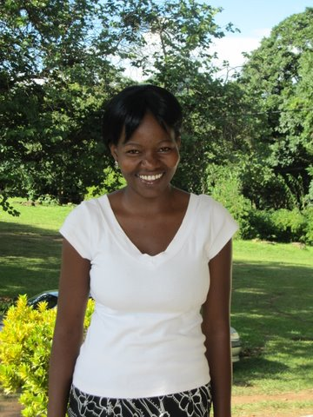
The project has received much help from ex Nchima agricultural graduate Steven Wasili, a very friendly and motivated young man. There are plans for mature agriculture students from the Development Aid from People to People organisation to attend the Centre. The Trust is paying for a number of DAPP students.

At the moment, two Nchima Trust sponsored agricultural graduates are coaching the farm workers, and it is rewarding to see the education we support being put to good use.
Liberator Chirwa, in her final year as a Social Science student at Chancellor University

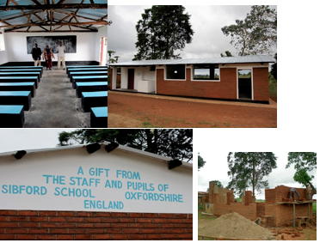
Everyone involved wants the farm to be a source of income for the Centre. Planting methods have been changed; new beds are being refilled with manure as part of the process of identifying sustainable methods of agriculture which can be replicated in the local community.

Thyolo’s market is being renovated and we hope to obtain a stall for the Centre’s products. Our neighbouring farmer has agreed to share access to his waterhole, and we are working closely with the local church to support their plans for a small carpentry school.
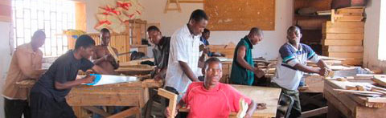
We hope our collaborations will encourage further learning and co-operation. As Frank Mkumba says, “Nchima does not give us the fishing net, but it gives us knowledge to make it and use it”.
Aaron Chisale and colleagues at the DAPP vocational training school
A School kitchen and homework room built at Ntambanyama School with funds raised by Sibford School, UK

Students’ Conference day: We held a conference day in March for all past and present Nchima Trust students. The guest lecturer was Mrs Vera Chirwa, the first female lawyer in Malawi, who played a leading role with her husband Orton in the campaign for the country’s independence in 1964. It was a moving occasion, and she enjoyed talking to the students at the meal afterwards. The talks, and Frank Mkumba’s attractive display of Nchima’s activities, were well received.

It’s hoped we will continue to organise one Nchima day a year. The discussions generate a great deal of enthusiasm and energy, and also provide an important networking opportunity for those looking for work.

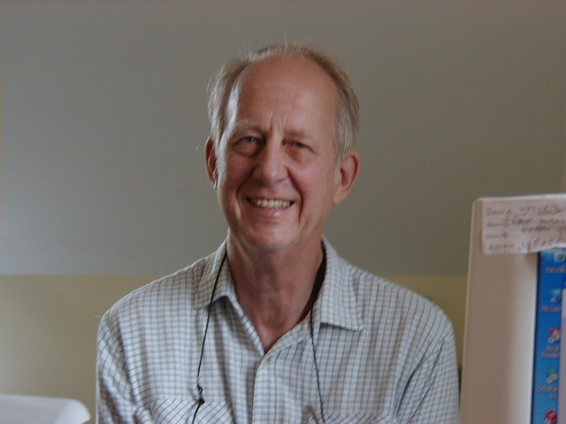
“We all want to learn to write”

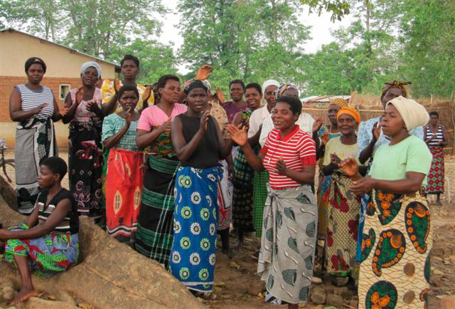

This report comes from Sharifin Gardiner, a longstanding Trustee who recently returned from a long-overdue visit to Malawi, including Chinyama, a remote area in the south:

It was a joy to meet so many friendly and warm-hearted Malawians, and several quite outstanding people. Our considerable network of volunteers in Malawi allows us to maintain close contact with the Trust’s beneficiaries. Chinyama has benefited from a number of Nchima donors who have provided education fees, ambucycles and community buildings.

AIDS affects many Malawians. Orphans are mostly looked after by siblings or grand-parents, aunts and uncles or other family members. However, many are also seen as a burden and are ostracised by society, so our providing orphan support helps ease the pain of losing parents and the sense of alienation.

Along with Rosina Kazambe, who assists with interviews of prospective Nchima-sponsored students, Sammy Malata our Mulanje contact and Jeannette Heikens, our hard working local representative, I reached Chinyama, hot and dusty after 45 minutes on a dirt road south of the main Limbe-Mulanje road. This is a depressed area with little but subsistence agriculture on greyish sandy soils. As we arrived, we saw hundreds of children in the road on their way home from school. We later found out how many there were: 2,000 primary and 200 secondary pupils.

The local Community Based Organisation, which deals with orphans, “grannies”, HIV patients, school leavers and sports, had applied to the Trust for funds to repair their adult literacy classroom and activities building. We were greeted by a group of women dancing and singing “Welcome, welcome” in Chichewa. This was because we support 7 girls at the secondary school (we’ll support 3 more next year), and we have supplied seed and fertilizer to grow maize on land donated by the chief for grannies to feed the orphans in their care.

The building has been built with only one layer of poor quality bricks and sub-standard mortar, which is why the end wall had fallen out. The women want to use the hall as a crèche for the orphans in the mornings so the grannies can go out to work. They will feed the orphans there, use it as an office and meeting place and later hold adult literacy classes.

During a long, formal meeting under a large tree, where our party and local dignitaries sat in a semi circle, the women intermittently broke into song and dance. It was both funny and deeply touching. The secondary school headmaster would call on speeches to be made, and the women would get up, dance and sing, “We all want to learn to write. We will help with the work”. Three elderly lady chiefs were present, and when the seven secondary school girls came up and shook us by the hand, one of them, Ziona, recited a her own poem (see p4).

Jeannette had bought some footballs for the boys, but the women laughed and said they wanted one for themselves. There were cheers when one of our ex-students, who wants to be a teacher, volunteered to run the adult literacy classes.

Everyone accepted there should be a signed agreement listing the responsibilities of both parties. This is very important so that people really feel they have ownership of the building. We plan to support two young men to take a 4 month brick-making course, so they can rebuild the community hall. Advice on supervision and design will sought from their teacher at Mikolongwe College.

We then crowded into the headmaster’s small office and met the seven Nchima-sponsored girls and their guardians. Much clapping greeted the announcement that they had all passed their latest exams. Sadly, however, pinned to the door outside was a list of marks for one class who had all failed their maths exams, probably because there had been no one to teach them.
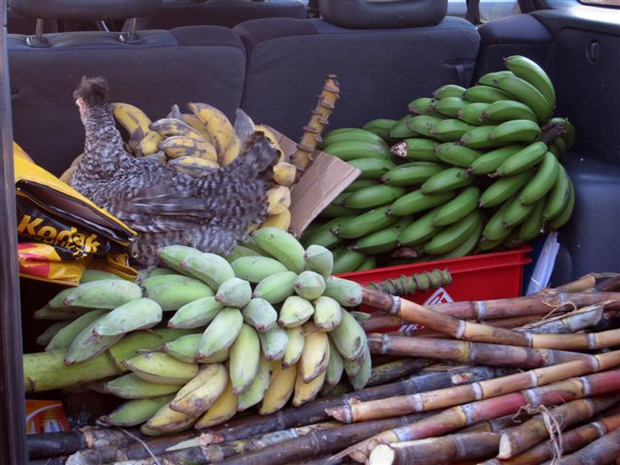
When we set off to leave, we found the car had been loaded up with presents from the girls’ parents or guardians, including two large bunches of bananas, sweet potatoes, sugar cane and cassava, and a vociferous young chicken that squawked most of the way back.

As we drove away, we passed the CBO Chairman cycling to a funeral; an all too frequent occurrence because of the AIDS epidemic.
Dear Reader, all our thanks go to you for your support and donations, without which we could never achieve all that we do in Malawi.

Cheques can be made out to Nchima Trust and sent to Josie Quinn, 3 Close Cottages, Knock,
Cumbria, CA16 6DL

Or you can pay online through Paypal on a Gift Aid form at www.nchimatrust.org

Name: ……………………………………………………
Address: …………………………………………………
……………………………………………………………
Email: ……………………………………………………
I hope the Nchima Trust can find the money to enter into a long term relationship with this deprived though active community.

Sharafin Gardner – October 2010

WHERE THE MONEY WENT 2009/10
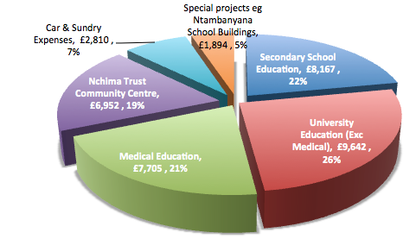

MY NEW HOME BY ZIONA
HOW CAN I EXPRESS MY HAPPINESS
AS I AM ON MY WAY TO THE LAND
OF RIVERS OF LOVE AND MERCY

BROUGHT BY THE NCHIMA FRIENDS
LAND WHERE PEACE IS BREAD
AND JUSTICE, A DRINK FOR ALL

WHAT ELSE CAN I SAY
AS I AM STEPPING TO MY NEW WORLD
WHERE POVERTY AND ILLITERACY WILL BE HISTORY?

WITHOUT THESE KIND HEARTED FRIENDS
I COULD HAVE NOTHING TO DO
FRIEND IN NEED, IS A FRIEND INDEED

(MAY THE ALMIGHTY GOD BLESS YOU ABUNDANTLY) CHINYAMA OCT 2010

